**Exercise 1 = 20 mts**

Given the set of vertices and the set of edges of the graph G=(V,E) as follows.

V = { 1, 2, 3, 4, 5, 6, 7 }

E = { (1,2), (1,3), (1,4), (2,5), (3,1), (3,5), (3,6), (4,6), (5,7), (6,3), (6,5), (6,7) }.

(a) Draw graph G, using either pen and paper or a software drawing tool, e.g. Draw.io <https://app.diagrams.net/>

(b) Create the adjacency matrix for graph G, using either pen and paper or a software tool.

(c) Create the adjacency list for graph G, using either pen and paper or a software tool.

**Exercise 2 – 20 mts**



a) Use **BFS** and write out the nodes that will get visited with their weights for each path. There might be more paths than one.

**Exercise 3 – 20 mts**

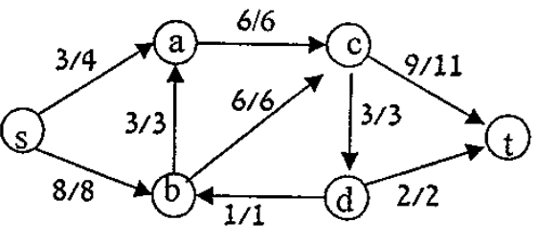

Answer the following questions based on the graph given above.

1. What are the sink node and source node of this graph?
2. What are the capacities of the following?
   1. c(s,a)
   2. c(s,b)
   3. c(a,c)
   4. c(b,c)
   5. c(c,t)
3. What are the flows of the following?
   1. f(s,a)
   2. f(b,d)
   3. f(a,c)
   4. f(b,c)
   5. f(t,c)
4. Compute, f(c,s)+f(c,a)+f(c,b)+f(c,d)+f(c,t). Justify whether the flow is conservative.
5. What is the value of the flow of this graph?
6. Draw the residual graph for the given graph above.